Safety Data Analytics -TMES 2023

Rishabh Mishra

S S V K S S Jyothiraditya

Q1.

1. Gangue associated with top 5 most available minerals in India –

**Iron -** Calcite', ' Chlorite', ' Epidote', ' Fluorite',

' Limonite', ' Malachite', 'Pyrite', ' Pyrrhotite', 'Biotite',

' Plagioclase', ' Pyroxene', 'Dolomite', ' Quartz', ' Dolomite',

' Garnet', 'Garnet', 'Quartz', 'Epidote', ' Feldspar', 'Andradite',' Apatite', ' Chalcedony', ' Tourmaline', 'Actinolite',' Stilpnomelane', 'Kaolin', ' Pyrite', ' Clay', ' Marcasite','Clay', 'Marcasite', 'Amethyst', 'Chert', 'Palladium', ' Platinum',' Sand', 'Goethite', 'Apatite', ' Calcite', ' Talc', 'Barite',' Chalcopyrite', ' Siderite',, 'Aragonite', ' Gypsum','Magnesite', ' Serpentine', ' Diopside', 'Gypsum', ' Limestone','Kaolinite', ' Muscovite', ' Phlogopite', 'Malachite', 'Augite',' Hematite', ' Martite', 'Phyllite', ' Schist', ' Biotite',' Ilmenite', 'Limonite', , ' Forsterite', ' Tremolite','Phlogopite', 'Ankerite', ' Barite', ' Graphite', 'Magnetite'' Scapolite', ' Wollastonite', 'Hornblende', 'Siderite',' Microcline', 'Pyroxene', 'Pyrrhotite', ' Hornblende', 'Feldspar',' Sericite', 'Hematite', 'Fluorite', 'Quartzite', 'Albite''Jasper', 'Chalcopyrite', ' Sphene', 'Chalcedony', ' Opal', 'Sand',' Vesuvianite', 'Chlorite', ' Olivine', ' Selenite',' Grossularite', 'Serpentine', 'Pleonaste', ' Monazite','Psilomelane', ' Pyrolusite', ' Quartzite', 'Chondrodite', ' Mica','Brucite', ' Spinel', ' Ankerite', ' Chert', 'Martite',' Andradite', ' Bornite', ' Galena', ' Sandstone', ' Magnetite',' Alunite', 'Mica', ' Hypersthene', ' Kyanite', 'Muscovite',' Augite', 'Chrysocolla', ' Specularite', ' Spessartite',' Zircon', 'Tuff', ' Ottrelite', 'Kyanite', 'Shale', 'Olivine',' Actinolite', ' Grunerite', ' Manganite', ' Gahnite',' Sillimanite', ' Copper', ' Rutile', ' Silver', 'Ilmenite','Alabandite', ' Halite', ' Psilomelane', ' Aragonite',' Chamosite', ' Cliachite', ' Gibbsite', ' Rhodochrosite', 'Corundum', ' Staurolite', ' Albite', ' Amphibole', 'Graphite’,'Andalusite', 'Allanite', 'Sphalerite', ' Asbestos', 'Gneiss',

' Gneiss', ' Rhodonite', ' Syenite', 'Plagioclase', ' Greenalite',

' Minnesotaite', 'Schist', ' Lignite', ' Kaolin', 'Diopside',

' Jasper', 'Arsenopyrite', 'Ocher', ' Wernerite', 'Hemimorphite','Granite', ' Oligoclase', ' Orthoclase', ' Clinozoisite', 'Asbestos'

**Aluminium – NO Gangue**

**Copper -**  :'Quartz', ' Sericite', 'Calcite', ' Quartz', ' Siderite', 'nan',

' Epidote', ' Garnet', ' Magnetite', 'Epidote', ' Graphite',

'Diopside', ' Pyrite', ' Pyrrhotite', 'Pyrite', ' Scapolite',

' Hematite', 'Garnet', 'Pyrrhotite', 'Limonite', 'Chlorite',

'Augite', 'Actinolite', ' Chlorite', 'Ankerite', ' Marcasite',

' Schist', 'Magnetite', 'Pyrolusite', ' Diopside', ' Wollastonite',

' Gypsum', ' Molybdenite', ' Powellite', ' Tetrahedrite',

' Specularite', 'Malachite', ' Dolomite', 'Aragonite', ' Calcite',

' Stilbite', ' Prehnite', ' Pyroxene', ' Zeolite', ' Malachite',

' Tourmaline', 'Gypsum', ' Biotite', 'Goethite', 'Jasper',

'Hematite', 'Barite', ' Rhodochrosite', 'Wollastonite', 'Ilmenite',' Fluorite', 'Agate', ' Chalcedony', ' Kaolinite', 'Kaolin','Celestite', ' Limonite', ' Jasper', 'Siderite', 'Iron', 'Albite',' Barite', ' Plagioclase', 'Fluorite', 'Biotite', ' Orthoclase','Dolomite', 'Chalcopyrite', ' Sulfur', 'Hornblende', 'Apatite',' Feldspar', ' Grossularite', ' Hornblende', ' Vesuvianite','Anthophyllite', ' Apatite', ' Clinozoisite', ' Cordierite',' Sillimanite', ' Sphene', ' Spinel', ' Tremolite', ' Clay',' Muscovite', ' Staurolite', ' Marble', ' Talc', 'Glauconite',' Labradorite', ' Rutile', ' Zircon', 'Sillimanite', ' Albite',' Pyrolusite', ' Microcline', ' Vermiculite', ' Iron','Chalcocite', ' Chrysocolla', ' Peat', 'Enargite', ' Jarosite','Anhydrite', ' Forsterite', ' Scheelite', ' Humite', 'Shale','Sandstone', 'Conglomerate', ' Shale', 'Anorthosite', 'Granite','Diabase', 'Limestone', ' Sandstone', ' Limestone', 'Andesite',' Goethite', 'Serpentine', 'Galena', ' Augite', 'Clay', 'Dioptase','Andradite', 'Antigorite', ' Phlogopite', 'Chalcedony'' Hedenbergite', 'Alunite', 'Specularite', 'Kaolinite', ' Opal','Muscovite', ' Serpentine', 'Sericite', ' Zoisite', ' Sphalerite',' Axinite', ' Nontronite', ' Mica', 'Axinite', 'Rutile'' Dickite', ' Halloysite', 'Caliche', 'Andalusite', ' Kaolin''Orthoclase', 'Sulfur', 'Feldspar', 'Plagioclase', 'Jarosite',' Oligoclase', ' Tenorite', ' Ilmenite', ' Lepidocrocite',' Turquoise', ' Psilomelane', 'Tourmaline', ' Halite', 'Tremolite''Braunite', ' Uraninite', 'Cubanite', ' Olivine', 'Opal','Forsterite', ' Beryl', ' Clinochlore', ' Pyrophyllite',' Celestite', ' Idocrase', 'Chrysotile', 'Gahnite', ' Pigeonite','Sphene', ' Natroalunite', ' Quartzite', ' Anhydrite',' Aragonite', ' Dioptase', ' Montmorillonite', ' Selenite','Bornite', ' Chalcopyrite', ' Bismuth', ' Chert', 'Talc','Anglesite', ' Blodite', ' Epsomite', ' Mirabilite', ' Soda Niter',' Wulfenite', 'Gold', ' Gold', ' Silver', 'Molybdenite','Asbestos', ' Pumpellyite-(Mg)', ' Laumontite', ' Cuprite',' Datolite', ' Atacamite', ' Melaconite', ' Phyllite', 'Chert',' Chalcocite', ' Covellite', ' Kyanite', ' Galena', 'Azurite',' Actinolite', ' Arsenical Copper', 'Prehnite', ' Domeykite','Scapolite', ' Anthophyllite', ' Antlerite', 'Cymrite',' Stilpnomelane', 'Coal', ' Rhodonite', ' Wad', 'Kyanite','Anatase', 'Graphite', 'Cinnabar', ' Dumortierite', 'Cuprite',' Arsenopyrite', 'Olivenite', 'Hedenbergite', 'Allophane',' Alunite', 'Amphibole', ' Clinopyroxene', ' Adularia',' Analcime', ' Apophyllite'

**Manganese – ‘**Quartz', 'Hematite', ' Quartz', 'Biotite', ' Feldspar',

'Goethite', 'Calcite', ' Chlorite', ' Laumontite', ' Dolomite',

' Pyrite', 'Pyrite', 'Barite', 'Feldspar', ' Muscovite',

'Dolomite', 'Chalcopyrite', ' Chert', ' Calcite', ' Galena',

' Sphalerite', ' Mica', ' Kaolinite', 'Epidote', ' Hematite',

'Alunite', ' Gypsum', 'Apatite', ' Goethite', ' Illite',

' Siderite', 'Chlorite', ' Sericite', 'Garnet', ' Garnet',

' Magnetite', ' Pyroxene', ' Sillimanite', ' Jasper', 'Magnetite

' Spessartite', 'Acmite', ' Albite', ' Barite', ' Montmorillonit

' Rhodochrosite', ' Fluorite', ' Chalcedony', 'Clay', ' Limonite

' Clay', 'Limonite', 'Jasper', ' Opal', ' Limestone', 'Wad',

' Iron', ' Sulfur', 'Chalcedony', 'Kaolin', 'Iron', ' Gold',

'Limestone', ' Chalcopyrite', ' Malachite', ' Zeolite', 'Gypsum'

'Cinnabar', 'Chert', ' Marcasite', 'Serpentine', 'Bementite',

' Rhodonite', 'Rhodonite', 'Pyrolusite', 'Aragonite', ' Epidote'

' Specularite', ' Piedmontite', ' Ilmenite', 'Montmorillonite',

' Nontronite', 'Zeolite', ' Hornblende', 'Kaolinite', 'Graphite'

' Tourmaline', 'Illite', ' Turquoise', 'Boehmite', ' Groutite',

' Lithiophorite', ' Celestite', 'Sand and Gravel', ' Gibbsite',

' Microcline', 'Fluorite', ' Diaspore', 'Glaucophane',

'Chalcocite', ' Copper', ' Cuprite'

**Silica -**  'Pyrite', 'Tourmaline', 'Ilmenite', ' Magnetite', ' Sphene',

'Calcite', ' Clay', 'Ankerite', ' Calcite', 'Clay', ' Sericite',

'Limonite', ' Mica', 'Dolomite'

1. **Approach –** Segregating on the basis of the column ‘dev_stat’ inferred as development status and then splitting ‘commod2’ and ‘commod3’ on the basis of commas and parsing the string for detecting silver in the United States

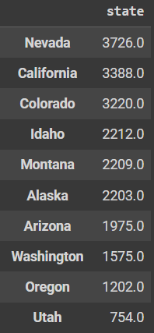

1. 'Korea, South', 'Japan', 'Mongolia', 'Afghanistan', 'Thailand',

'Korea, North', 'China', 'Laos', 'Cambodia', 'Philippines',

'Vietnam', 'India', 'Taiwan', 'Burma'

1. L
2. L

Q2. States of the world where gold is the most abundant mineral that can be mined in future.

Approach – We looked at the prospect since they indicate that they can be mined in the future and occurrence can’t necessarily be mined in the future, searched for gold in commod1 which would make it the most abundant mineral on the site, plotted them on the world map.

North America has high potential for mining gold in the future.

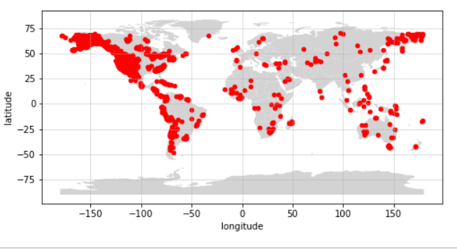

**Q3.**

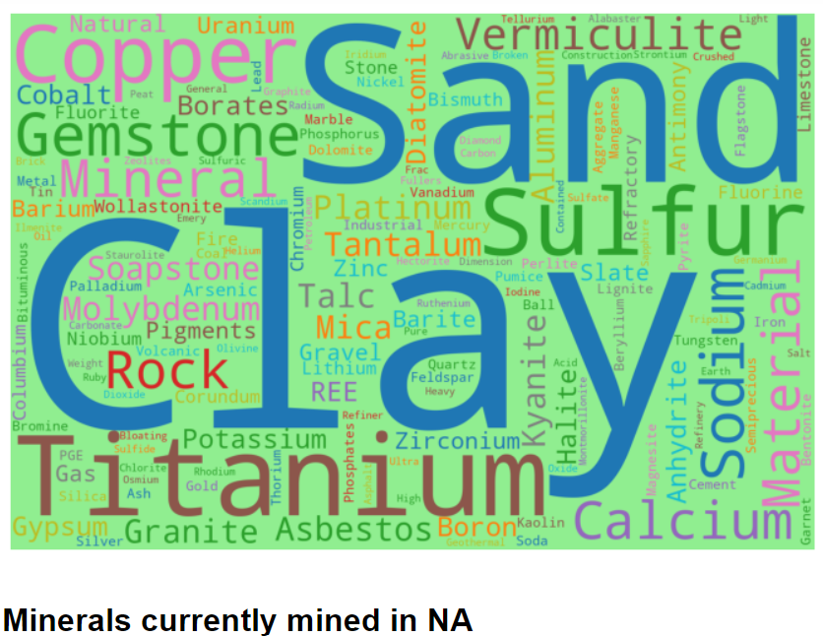

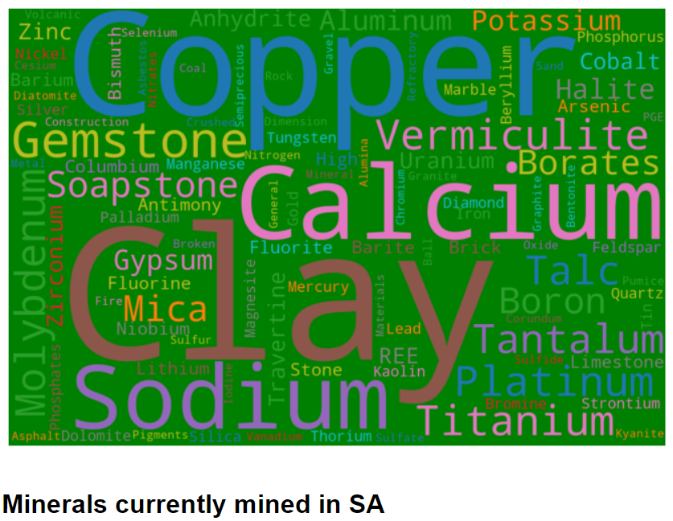

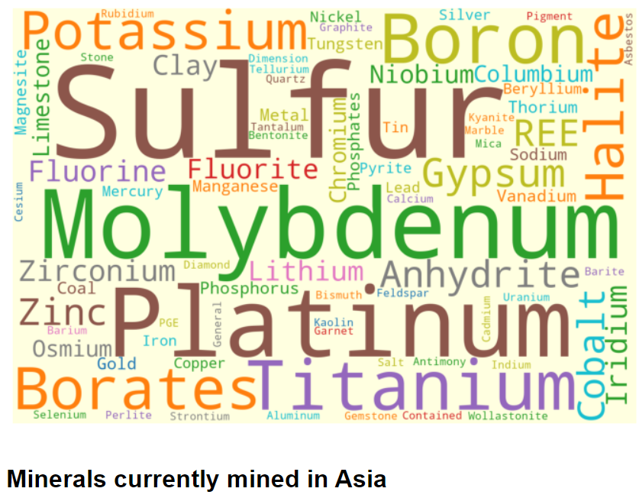

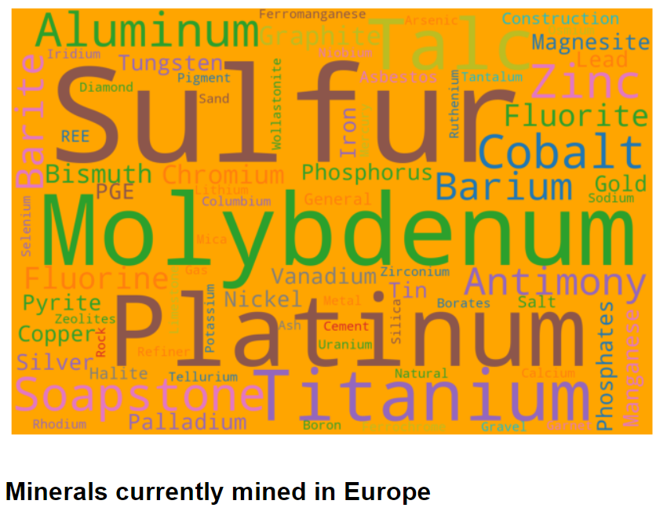

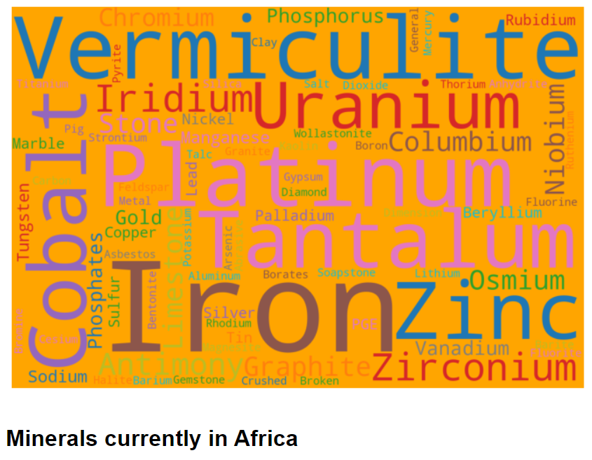

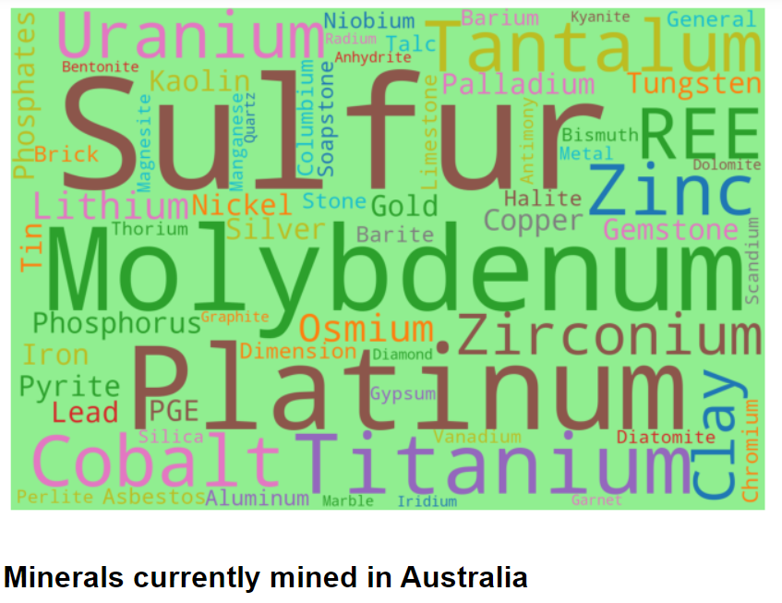

Although CR (Caribbean) was given as a separate region, in order to maintain consistency, we have considered CR to be a part of NA. There was one entry with region = ‘EU, AS’ , we have dropped that entry.

Q3.

b) 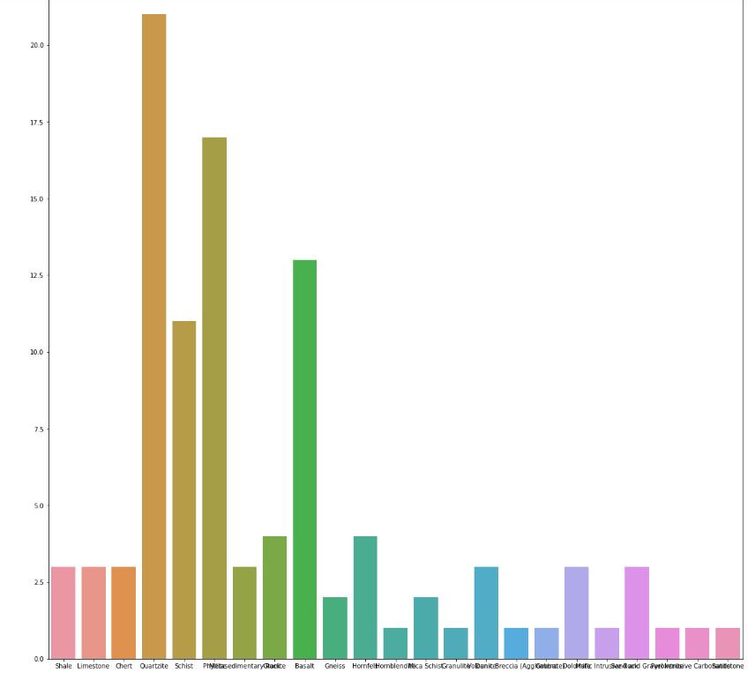

# Quartzite

# Phyllite

# Basalt

# Schist

# Hornfelt

Q3. C) Looked for rows where gold and copper (might be with other minerals) lied in ‘commod1’ and the parsed ‘commod2’ and ‘commod3’ for the by product minerals, worked with the dataframe where country = ‘United States’

